Yr 12 General Integrated Science
TASK 10 – Factors affecting severity of collisions

Every day hundreds of car collisions take place globally. Some individuals survive the collision; others are not so lucky. What determines the severity of injuries sustained by drivers and passengers depends on many factors.

Your task is to investigate ONE factor that can affect severity of a car collision. These factors include:
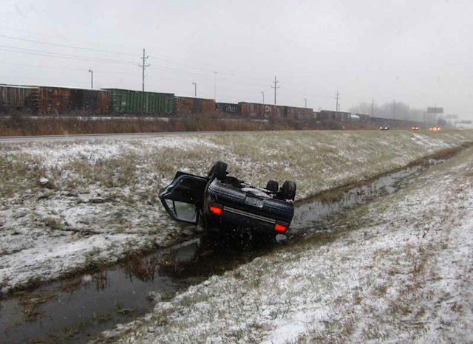
Speed;
Road surface;
Condition of tyres;
Seatbelts;
Crumple zone;
Air bags;
Driver’s reaction time, and
Brake efficiency.

Design your investigation to determine how ONE factor will influence the forces generated by the collision. You may choose to investigate the effects on the vehicle OR on the passengers and driver.

Consider what you need to measure for your data collection; e.g. if you are recording velocity you will need to use a timer and a tape measure to record distance and time and then use the formula to work out velocity.

Suggestions:
- You may use trolleys and ramps to alter the speed of the vehicle. You can use dummies.
- Test the effect of increasing velocity on plasticine dummies or a barrier.
- You can create crumple zones, seat belts, air bags to conduct crash tests.
- You can ride your bike to test the effect of different types of surfaces on braking distance (wet; sand; grass; bitumen).
- Use a pedometer to test the effect of speed on braking distance.
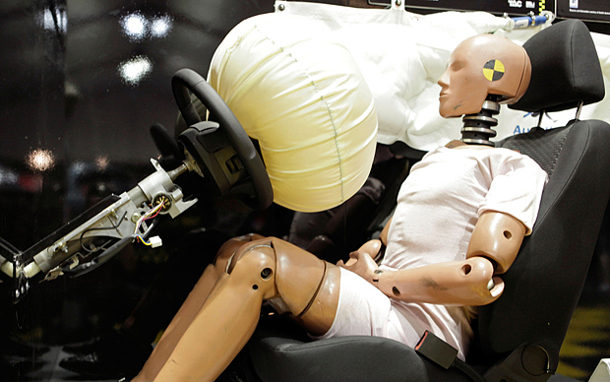
You might consider doing preliminary trials to identify any issues that need to be addressed.

Due date: Friday 26 August – Week 6 Term 3.

